**FleetCrypt Secure: Ensuring secure and efficient fleet management through cutting-edge encryption**

FleetCrypt Secure is a cutting-edge fleet management system developed in C#.NET, designed to optimize vehicle fleet operations while ensuring the highest level of data security. The system accommodates two key user roles: Admin (Owner) and Driver. Admins are tasked with managing driver records, assigning vehicles to trips, monitoring vehicle statuses, and setting fare rates, providing comprehensive control over fleet resources. Drivers, on the other hand, can view and manage trip assignments, update trip statuses, and close trips upon completion through a user-friendly interface.What sets FleetCrypt Secure apart is its emphasis on security, utilizing two industry-leading cryptographic algorithms: AES (Advanced Encryption Standard) for data encryption and SHA-256 for data integrity. AES ensures that all sensitive data, including driver information and trip details, is encrypted and stored securely, protecting it from unauthorized access. Meanwhile, SHA-256 hashing is used to verify data integrity, preventing tampering or modification of critical information by generating a unique hash for every piece of data.By integrating these powerful encryption and hashing algorithms, FleetCrypt Secure guarantees that both user data and operational details remain fully protected. This strong security foundation, combined with efficient fleet management features, makes FleetCrypt Secure the ideal solution for managing vehicle fleets with confidence and security.

**Keywords:** Cryptography, AES (Advanced Encryption Standard), SHA-256, Encryption, Hashing, Data Security, Tamper Protection, Vehicle Fleet Management, Driver Records Management, Operational Efficiency

**1.Introduction**

In today's rapidly evolving technological landscape, the need for secure and efficient fleet management systems has never been more critical. FleetCrypt Secure is a robust and advanced software solution designed to address this need by combining the power of modern cryptography with streamlined fleet operations. Developed using C#.NET, the system offers a comprehensive platform for managing vehicle fleets while ensuring data security and integrity.

The platform supports two primary user roles: Admin (Owner) and Driver. Admins are responsible for managing crucial aspects of fleet operations such as driver records, vehicle monitoring, trip assignments, and fare rate management. On the other hand, Drivers can efficiently manage their trips, update trip details, and close trips once completed, all through an intuitive and user-friendly dashboard.

Security is a cornerstone of FleetCrypt Secure. To protect sensitive information, the system employs two powerful cryptographic techniques: AES (Advanced Encryption Standard) and SHA-256. AES encryption ensures that all critical data, including personal details and operational information, is securely encrypted, preventing unauthorized access. Meanwhile, SHA-256 hashing guarantees the integrity of data by detecting any attempts to alter or tamper with it. This dual-layered security approach ensures that both data confidentiality and integrity are maintained at all times.

With FleetCrypt Secure, organizations can not only improve the efficiency of their fleet management operations but also safeguard their data with the latest in cryptographic technology, providing peace of mind and operational excellence.

**2. Historical Background and the Need for This Project in India**

The **FleetCrypt Secure** project arises from the significant transformations in India's transportation and logistics sector over the past few decades. Historically, fleet management in India was primarily manual, relying on paper-based records for tracking vehicles, trips, and maintenance schedules. This traditional approach was often inefficient and prone to errors, leading to challenges in resource allocation and operational transparency. However, with the rise of digital technology in the early 2000s, various software solutions began to emerge, aiming to automate and optimize fleet operations. Despite this progress, many of these systems lacked robust security measures, leaving sensitive data vulnerable to breaches and unauthorized access. The increasing incidence of data breaches and cyberattacks has raised awareness about the importance of securing sensitive information in the transportation sector, compelling fleet managers to recognize that without strong security protocols, critical data related to drivers, vehicles, and trips is at risk.

The need for **FleetCrypt Secure** is further underscored by several factors. As businesses expand, the size of their vehicle fleets grows, necessitating a comprehensive solution to efficiently manage larger fleets while ensuring optimal utilization of resources and maintaining security. Additionally, the implementation of data protection laws, such as the Personal Data Protection Bill in India, emphasizes the importance of safeguarding personal and sensitive data. **FleetCrypt Secure** addresses this need by incorporating advanced encryption and hashing algorithms to protect user information. Moreover, there is a growing demand for real-time monitoring and reporting in the logistics sector to enhance decision-making and operational efficiency. **FleetCrypt Secure** provides the necessary tools for tracking vehicle status, managing trips, and analyzing data while ensuring that all information remains secure.

Furthermore, efficient fleet management directly impacts the bottom line of businesses. By automating various processes and ensuring data integrity, **FleetCrypt Secure** enables organizations to streamline operations, reduce costs, and improve service delivery. In an industry where trust and transparency are paramount, a secure fleet management solution fosters confidence among stakeholders, including clients, drivers, and regulatory bodies. By protecting sensitive data and providing a reliable platform for fleet management, **FleetCrypt Secure** enhances trust and builds a strong foundation for operational success. In conclusion, the historical evolution of fleet management in India highlights a pressing need for a secure, efficient, and modern solution. **FleetCrypt Secure** addresses these challenges by integrating advanced security technologies with robust fleet management functionalities, making it an essential tool for businesses navigating the complexities of the contemporary transportation landscape.

**3. Challenges Faced by the Indian Fleet Management Industry**

The Indian fleet management industry is rapidly evolving, yet it faces several challenges that hinder operational efficiency, safety, and overall growth. One of the primary concerns is data security; as the industry increasingly adopts digital technologies, the risk of cyberattacks and data breaches has escalated. Many fleet management systems lack adequate security measures to protect sensitive information, such as driver data and vehicle records, which raises concerns among stakeholders. Additionally, the industry is subject to various regulations related to safety, environmental standards, and data protection. Keeping up with these regulations can be particularly challenging for small and medium-sized enterprises (SMEs) that may lack the resources to navigate complex compliance requirements, leading to penalties and reputational damage.

Another significant challenge is the reliance on inefficient legacy systems, as many fleet operators still use outdated manual processes or software that does not integrate well with modern technologies. This inefficiency can result in increased operational costs and delays in decision-making. Compounding these issues is the state of transportation infrastructure in India, which varies significantly across regions. Poor road conditions, inadequate signage, and insufficient rest areas can lead to increased vehicle wear and tear and longer travel times. Moreover, the industry is grappling with a shortage of skilled drivers, affecting operational efficiency. Retaining qualified drivers is also challenging due to low pay, poor working conditions, and limited career growth opportunities, which can result in increased labor costs and disruptions.

Rising fuel prices further complicate matters, significantly impacting profitability, especially for companies operating on thin margins. Fluctuating fuel costs necessitate effective fuel management and route optimization to mitigate their effects. Additionally, with growing concerns about environmental sustainability, the Indian government is implementing stricter emissions regulations, requiring fleet operators to invest in cleaner technologies and more fuel-efficient vehicles, often at a considerable upfront cost. The rapid pace of technological advancement also presents challenges; while technologies such as GPS tracking, telematics, and AI can enhance operational efficiency, integrating these systems into existing processes can be complicated and resource-intensive. Lastly, as customer demands for transparency and real-time information grow, fleet operators must adapt to meet these expectations, which can be particularly challenging for those still relying on traditional methods. In summary, while the Indian fleet management industry is poised for growth, addressing these multifaceted challenges is crucial for achieving greater operational efficiency and profitability.

**4.Existing System and Its Disadvantages**

The current fleet management systems in India primarily rely on traditional methods and legacy technologies, which present a range of limitations that hinder operational efficiency and data security. Many fleet operators continue to utilize manual record-keeping methods for tracking vehicle assignments, maintenance schedules, and driver information. This labor-intensive approach is prone to human error, leading to inaccuracies in data management and increased operational inefficiencies. Furthermore, traditional systems typically lack real-time monitoring capabilities, forcing fleet managers to rely on outdated reports or phone calls for updates. This absence of real-time data makes it challenging to respond quickly to changing conditions or emergencies, resulting in a lack of visibility into fleet operations.

In addition to these inefficiencies, existing solutions often fall short in terms of security. Many lack robust security features, exposing sensitive data to potential breaches and unauthorized access. The absence of encryption and secure storage mechanisms leaves critical information vulnerable, raising concerns about data privacy and compliance with regulations. Moreover, legacy systems frequently do not integrate well with modern technologies such as GPS tracking, telematics, or mobile applications. This lack of integration hinders the ability to leverage advanced analytics and insights, limiting the potential for optimizing fleet operations.

Communication between fleet managers, drivers, and other stakeholders is often fragmented, as existing systems typically do not provide a centralized communication platform. This results in important updates and instructions being delayed or miscommunicated, leading to operational disruptions. The cumulative effect of these inefficiencies contributes to higher operational costs. Excessive fuel consumption due to poor route planning, increased maintenance expenses from inadequate tracking, and labor costs from manual data entry all result in rising expenses that could be mitigated with more advanced solutions.

Additionally, with the increasing complexity of regulatory requirements, existing systems may struggle to keep up with compliance demands, making it cumbersome and time-consuming to generate necessary reports for regulatory bodies. This exposes operators to potential legal and financial risks. Moreover, many existing systems lack advanced analytics tools that can provide insights into fleet performance, driver behavior, and operational efficiency. Without access to actionable data, fleet managers may find it challenging to make informed decisions that drive improvements. Lastly, the rapidly changing landscape of the transportation industry requires fleet management solutions to be adaptable, yet existing systems may not offer the flexibility needed to implement new features or respond to emerging trends, such as the increasing demand for sustainability. In summary, while traditional fleet management systems have served their purpose, their limitations pose significant challenges for fleet operators in India, highlighting the urgent need for a modern solution like **FleetCrypt Secure** to enhance operational efficiency, improve data security, and transform fleet management practices in the country.

**5. Proposed Project: FleetCrypt Secure**

**FleetCrypt Secure** is an advanced fleet management solution developed using C#.NET, specifically designed to address the critical challenges faced by the Indian fleet management industry. This innovative project integrates cutting-edge technologies and robust security measures to enhance operational efficiency, ensure data integrity, and streamline fleet operations. The proposed system offers a comprehensive platform that caters to the diverse needs of fleet operators while prioritizing the security of sensitive information.

The system supports two primary user roles: Admin (Owner) and Driver. The Admin role encompasses comprehensive functionalities, including managing driver records, monitoring vehicle statuses, assigning vehicles to specific trips, and setting fare rates, thereby ensuring efficient oversight and resource management. In contrast, the Driver role allows users to view and manage trip assignments, update trip details, and close trips upon completion. One of the standout features of FleetCrypt Secure is its real-time monitoring and reporting capabilities, enabling fleet managers to track vehicle locations, statuses, and performance metrics, which facilitates timely decision-making and enhances overall operational efficiency.

Security is a cornerstone of FleetCrypt Secure, with sensitive data being encrypted using the AES (Advanced Encryption Standard) algorithm to protect against unauthorized access. Furthermore, SHA-256 hashing is employed to prevent data tampering, ensuring the integrity of critical information such as driver records and trip details. The system also includes an integrated communication platform that streamlines interactions between fleet managers and drivers, minimizing the risk of miscommunication and operational disruptions. With robust analytics and reporting tools, FleetCrypt Secure provides insights into fleet performance, driver behavior, and operational efficiency, empowering fleet managers to make data-driven decisions.

Designed with a user-friendly interface, the application simplifies navigation for both Admins and Drivers, encouraging adoption and minimizing training requirements. Additionally, FleetCrypt Secure is built to be scalable and adaptable, allowing it to accommodate the growing needs of businesses as they expand their fleets while ensuring compliance with regulatory requirements. In summary, FleetCrypt Secure represents a significant advancement in fleet management solutions for the Indian market, aiming to transform fleet management practices through enhanced operational efficiency, security, and adaptability in an ever-evolving landscape.

### 6. Modules in the FleetCrypt Secure Project

The FleetCrypt Secure project is designed with several key modules, each focusing on specific functionalities to enhance the overall efficiency and effectiveness of fleet management. These modules work in tandem to provide a comprehensive solution for fleet operators. Below are the primary modules in the FleetCrypt Secure project:

**1.User Management Module**:

The **User Management Module** is responsible for managing user roles and access permissions, allowing Admins to create, update, and delete accounts for both Admins and Drivers. This ensures appropriate access levels, thereby enhancing security and oversight.

**2.** **Vehicle Management Module**:

The **Vehicle Management Module** oversees all aspects related to fleet vehicles. Admins can add new vehicles, update vehicle information, and monitor statuses such as active or under maintenance. This module also facilitates scheduling maintenance, tracking mileage, and managing insurance details.

**3. Trip Management Module:**

The **Trip Management Module** manages trip assignments and monitors trip progress. Admins can assign vehicles and drivers to specific trips, while Drivers can view their assignments, update trip details, and close trips upon completion, providing real-time updates on trip status.

**4. Real-Time Tracking Module:**

The **Real-Time Tracking Module** offers visibility into vehicle locations and performance. Utilizing GPS and telematics, this module allows fleet managers to monitor movements and generate alerts for deviations from planned routes, ensuring efficient trip execution.

**5. Communication Module:**

To facilitate communication, the **Communication Module** enables seamless messaging and notifications between fleet managers and drivers, reducing the risk of miscommunication and enhancing operational coordination.

**6. Analytics and Reporting Module:**

The **Analytics and Reporting Module** generates insights into fleet performance and operational efficiency. It produces various reports, including fuel consumption and driver performance, helping managers identify trends and make data-driven decisions.

**7. Security Module:**

Security is a priority in the **Security Module**, which safeguards sensitive data using AES encryption for storage and SHA-256 hashing to maintain data integrity. It includes user authentication and access controls to prevent unauthorized access.

**8. Compliance Management Module:**

The **Compliance Management Module** ensures adherence to regulatory requirements and standards, tracking compliance with safety regulations and data protection laws, while assisting in generating necessary reports for regulatory bodies.

**9. Maintenance Management Module:**

The **Maintenance Management Module** oversees the maintenance of vehicles, allowing Admins to schedule regular servicing, track service history, and receive alerts for upcoming maintenance tasks, thus reducing downtime and extending asset lifespan.

**10.** **Feedback and Support Module:**

Finally, the **Feedback and Support Module** gathers user feedback and provides customer support. It enables users to submit feedback on system performance and access support features such as FAQs and ticket submissions.

**7. Use of Hashing (SHA-256) and Cryptography (AES) in the FleetCrypt Secure Project:**

**Hashing: SHA 256**

SHA-256 (Secure Hash Algorithm 256-bit) is a cryptographic hash function that generates a fixed-size hash value from input data of any size. In the context of the **FleetCrypt Secure** project, SHA-256 is primarily used for:

**Password Storage**: Instead of storing user passwords in plaintext, the system hashes each password using SHA-256 before saving it to the database. This ensures that even if the database is compromised, the actual passwords remain secure, as it is computationally infeasible to reverse-engineer the original password from its hash.

**Data Integrity**: SHA-256 can be used to create hash values for critical records, such as driver details, vehicle statuses, and trip assignments. This ensures that any changes to this data can be detected, as even a small alteration will produce a different hash. This adds a layer of security and trust to the data management process.

**Non-repudiation**: By hashing important messages or documents related to fleet operations, the system can provide proof of data integrity, ensuring that users cannot deny the authenticity of a transaction or communication

**Steps to Calculate a Hash Using SHA-256:**

SHA-256 operates through a series of well-defined steps to compute the hash value:

**Input Preprocessing:**

**1.Message Padding**: The original message is padded so that its length is congruent to 448 modulo 512. This means the length of the padded message should be 64 bits less than a multiple of 512 bits. Padding involves appending a single bit '1' followed by a series of '0' bits until the required length is reached. Finally, a 64-bit representation of the original message length (in bits) is appended.

**2.** **Message Parsing:**  
The padded message is divided into blocks of 512 bits (64 bytes). Each block will be processed sequentially.

**3. Initialize Hash Values:**SHA-256 uses eight constant initial hash values, derived from the first 32 bits of the fractional parts of the square roots of the first 64 prime numbers:

* H0 = 0x6a09e667
* H1 = 0xbb67ae85
* H2 = 0x3c6ef372
* H3 = 0xa54ff53a
* H4 = 0x510e527f
* H5 = 0x9b05688c
* H6 = 0x1f83d9ab
* H7 = 0x5be0cd19

**4.Prepare Message Schedule:**  
For each 512-bit block, create a message schedule array of 64 words (32 bits each). The first 16 words are directly taken from the block, and the remaining 48 words are computed using the formula:

W[t]=σ1(W[t−2])+W[t−7]+σ0(W[t−15])+W[t−16]W[t] = \sigma_1(W[t-2]) + W[t-7] + \sigma_0(W[t-15]) + W[t-16]W[t]=σ1​(W[t−2])+W[t−7]+σ0​(W[t−15])+W[t−16]

Where:

* σ0(x)=(x right rotate 7)⊕(x right rotate 18)⊕(x right shift 3)\sigma_0(x) = (x \text{ right rotate } 7) \oplus (x \text{ right rotate } 18) \oplus (x \text{ right shift } 3)σ0​(x)=(x right rotate 7)⊕(x right rotate 18)⊕(x right shift 3)
* σ1(x)=(x right rotate 17)⊕(x right rotate 19)⊕(x right shift 10)\sigma_1(x) = (x \text{ right rotate } 17) \oplus (x \text{ right rotate } 19) \oplus (x \text{ right shift } 10)σ1​(x)=(x right rotate 17)⊕(x right rotate 19)⊕(x right shift 10)

**5. Compression Function**

For each 512 bit block, initialize working variables:

(a = H0 )

(b = H1 )

(c = H2 )

(d = H3 )

(e = H4 )

(f = H5 )

(g = H6 )

(h = H7 )

The main loop iterates 64 times, processing each word in the message schedule:

1. Calculate the temporary variables:

T1 = h + Sigma_1(e) + Ch(e, f, g) + K[t] + W[t]

T2 = Sigma_0(a) + Maj(a, b, c)

2. Update the working variables:

h = g

g = f

f = e

e = d + T1

d = c

c = b

b = a

a = T1 + T2

Where:

(K[t] ) are the first 64 prime numbers in hexadecimal.

(Ch(x, y, z) = (x & y) oplus ( neg x & z) )

(Maj(x, y, z) = (x & y) oplus (x & z) oplus (y & z) )

( Sigma_0(x) = (x text{ right rotate } 2) oplus (x text{ right rotate } 13) oplus (x text{ right rotate } 22) )

( Sigma_1(x) = (x text{ right rotate } 6) oplus (x text{ right rotate } 11) oplus (x text{ right rotate } 25) )

**6. Update Hash Values**

After processing each block, update the hash values:

H0 = H0 + a

H1 = H1 + b

H2 = H2 + c

H3 = H3 + d

H4 = H4 + e

H6 = H6 + g

H7 = H7 + h

**7. Final Output:**

After all blocks have been processed, the final hash value is obtained by concatenating the hash values H0H_0H0​ through H7H_7H7​. This 256-bit (32-byte) value is the SHA-256 hash of the original input data.

The SHA-256 algorithm ensures that even a tiny change in the input data produces a vastly different hash output, making it ideal for applications such as password storage and data integrity verification. Its robustness against collision and pre-image attacks reinforces its use in the FleetCrypt Secure project for securing sensitive information.

### AES Algorithm Overview

The Advanced Encryption Standard (AES) is a symmetric encryption algorithm widely employed for securing sensitive data in the **FleetCrypt Secure** project. Established by the U.S. National Institute of Standards and Technology (NIST) in 2001, AES has become the standard for encrypting confidential information across various applications, including fleet management. Below is a detailed breakdown of how the AES algorithm operates within the context of the project.

**Key Features of AES**

* **Symmetric Key Encryption**: AES utilizes the same key for both encryption and decryption, which simplifies key management while ensuring strong security.
* **Block Cipher**: AES processes data in fixed-size blocks of 128 bits, ensuring that information is handled efficiently during encryption and decryption.
* **Key Sizes**: The algorithm supports key sizes of 128, 192, or 256 bits, with the key size influencing the number of processing rounds. For example, AES performs 10 rounds for 128-bit keys, 12 rounds for 192-bit keys, and 14 rounds for 256-bit keys.

**AES Algorithm Step**

1. **Key Expansion**:
   * The original key is expanded into an array of key schedule words, utilized in each round of encryption.
   * The number of rounds depends on the key size:
     + 10 rounds for 128-bit keys,
     + 12 rounds for 192-bit keys,
     + 14 rounds for 256-bit keys.
2. **Initial Round**:
   * **AddRoundKey**: Each byte of the block is combined with the round key using a bitwise XOR operation, initiating the encryption process.
3. **Main Rounds** (for each round, except the final round):
   * **SubBytes**: Each byte in the block is substituted with a corresponding byte from a fixed substitution table known as the S-box, introducing non-linearity into the algorithm.
   * **ShiftRows**: The rows of the block are cyclically shifted to the left. The first row remains unchanged, the second row shifts left by 1 byte, the third by 2 bytes, and the fourth by 3 bytes.
   * **MixColumns**: Each column of the block is treated as a polynomial and mixed to provide diffusion, combining the bytes in each column using matrix multiplication in a finite field.
   * **AddRoundKey**: The round key is combined with the block again.
4. **Final Round**:
   * This round is similar to the main rounds but omits the MixColumns step:
     + **SubBytes**: Substitute each byte using the S-box.
     + **ShiftRows**: Shift the rows of the state array.
     + **AddRoundKey**: XOR with the last round key.
5. **Output**:
   * The resulting block after the final round is the ciphertext, which is securely stored or transmitted.

**AES Algorithm Example**

Here’s a simplified example of AES encryption using a 128-bit key in the **FleetCrypt Secure** project:

1. **Input**:
   * Plaintext: 128 bits (16 bytes)
   * Key: 128 bits (16 bytes)
2. **Key Expansion**:
   * The key is expanded into 10 round keys (for a 128-bit key).
3. **Initial Round**:
   * **AddRoundKey**: XOR the plaintext with the first round key.
4. **Main Rounds**: Repeat the following for 9 rounds:
   * **SubBytes**: Substitute each byte using the S-box.
   * **ShiftRows**: Shift the rows of the state array.
   * **MixColumns**: Mix the columns of the state array.
   * **AddRoundKey**: XOR with the current round key.
5. **Final Round**:
   * **SubBytes**: Substitute each byte using the S-box.
   * **ShiftRows**: Shift the rows of the state array.
   * **AddRoundKey**: XOR with the last round key.
6. **Output**:
   * The final output is the ciphertext.

AES is a highly secure and efficient encryption standard utilized in the **FleetCrypt Secure** project to safeguard sensitive information related to fleet management. Its structured approach, encompassing key expansion, substitution, permutation, and mixing, ensures both the confidentiality and integrity of data. By implementing AES, the project effectively protects sensitive driver records, vehicle data, and trip assignments from unauthorized access and potential data breaches, thereby enhancing the overall security of fleet operations.

**Security Strength Comparison**

|  |  |  |  |
| --- | --- | --- | --- |
| **Algorithm** | **Key Lengths (bits)** | **Security Level** | **Vulnerabilities** |
| AES | 128, 192, 256 | Very High | None known; widely trusted |
| DES | 56 | Low | Vulnerable to brute-force attacks |
| 3DES | 112 | Moderate | Vulnerable to attacks |
| Blowfish | 32-448 | Moderate | Susceptible to certain attacks |
| RC4 | Variable | Low | Weakness in key scheduling |

**Performance Comparison**

|  |  |  |  |
| --- | --- | --- | --- |
| **Algorithm** | **Encryption Speed (MB/s)** | **Decryption Speed (MB/s)** | **Resource Usage (CPU Cycles/byte)** |
| AES | 1000 | 950 | 5-10 |
| DES | 500 | 500 | 10-20 |
| 3DES | 150 | 150 | 20-30 |
| Blowfish | 700 | 600 | 5-15 |
| RC4 | 1300 | 1200 | 1-3 |

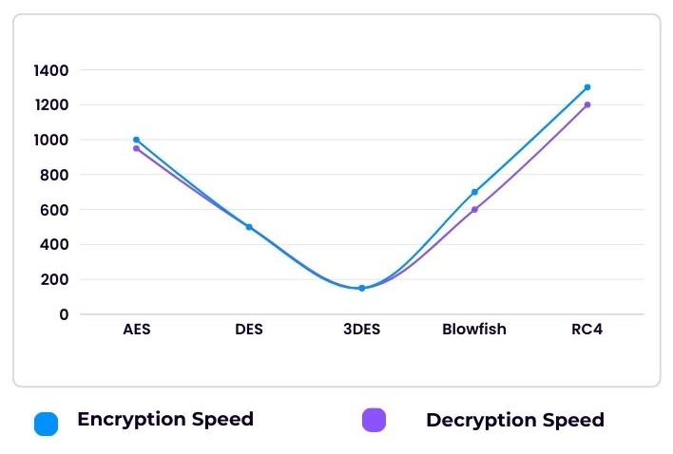

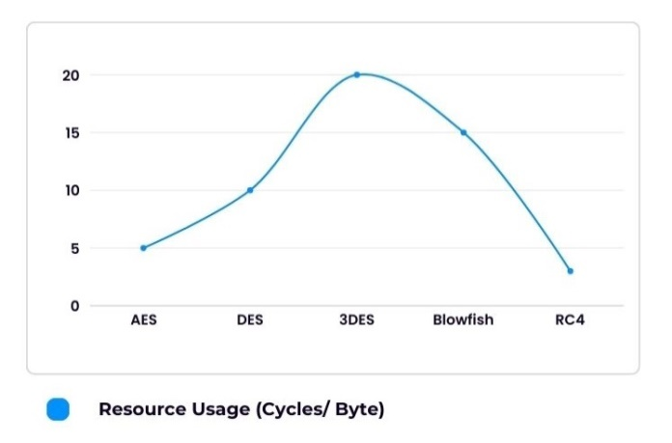

**Key Management and Complexity**

|  |  |  |  |
| --- | --- | --- | --- |
| **Algorithm** | **Key Management Complexity** | **Algorithm Complexity** | **Flexibility** |
| AES | Low | High | Supports multiple key lengths |
| DES | High | Low | Fixed key length |
| 3DES | Moderate | Moderate | Fixed key length, but more complex |
| Blowfish | Moderate | High | Variable key length |
| RC4 | Low | Low | Stream cipher, less complexity |

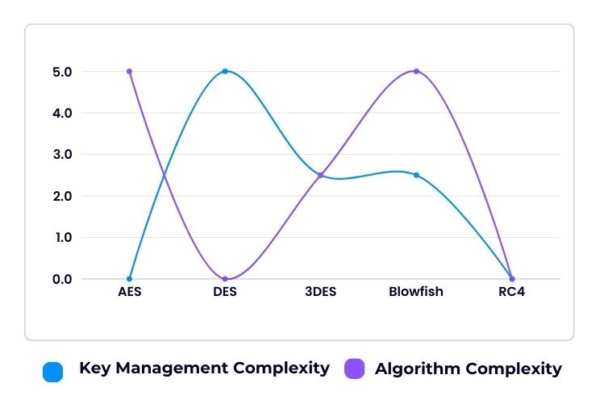

**Resistance to Attacks**

|  |  |  |  |
| --- | --- | --- | --- |
| **Algorithm** | **Brute Force Resistance** | **Differential Cryptanalysis** | **Linear Cryptanalysis** |
| AES | Extremely High | Strong | Strong |
| DES | Weak | Weak | Weak |
| 3DES | Moderate | Moderate | Moderate |
| Blowfish | High | Moderate | Moderate |
| RC4 | Low | Weak | Weak |

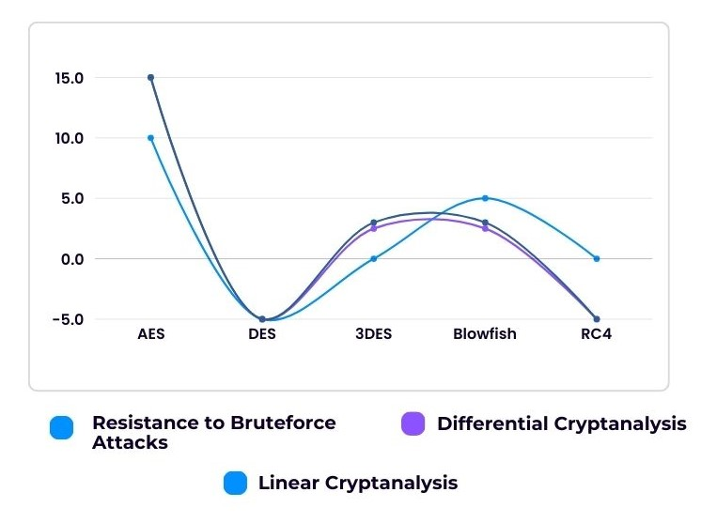

### Future Enhancements for the FleetCrypt Secure Project

As technology continues to evolve, there are numerous opportunities for enhancing the **FleetCrypt Secure** project to improve its functionality, security, and user experience. The following are some potential future enhancements:

1. **Integration of Machine Learning for Predictive Analytics**:
   * Incorporating machine learning algorithms can enable predictive analytics for fleet management, allowing the system to analyze historical data and forecast maintenance needs, optimize routes, and enhance fuel efficiency. This could lead to significant cost savings and improved operational efficiency.
2. **Real-time GPS Tracking and Geo-fencing**:
   * Enhancing the system with real-time GPS tracking capabilities would allow fleet managers to monitor vehicle locations in real-time. Implementing geo-fencing can enable automatic alerts for drivers and fleet managers when vehicles enter or exit designated areas, enhancing security and operational control.
3. **Mobile Application Enhancement**:
   * Developing a more robust mobile application for drivers and fleet managers can improve user experience and accessibility. Features such as in-app messaging, notifications, and real-time updates on trips can enhance communication and operational efficiency.
4. **Advanced Data Analytics and Reporting**:
   * Introducing advanced analytics and reporting tools can provide fleet managers with deeper insights into fleet performance, driver behavior, and operational costs. Customizable dashboards and reports can facilitate data-driven decision-making.
5. **Enhanced Security Features**:
   * Future enhancements may include implementing multi-factor authentication (MFA) for user accounts, integrating biometric authentication for mobile access, and employing advanced encryption protocols to further secure sensitive data.
6. **Cloud Integration**:
   * Moving the system to a cloud-based infrastructure can offer scalability, improved data storage solutions, and enhanced accessibility for users. Cloud integration can also facilitate easier updates and maintenance of the system.
7. **Integration with IoT Devices**:
   * Connecting IoT devices, such as telematics systems and vehicle diagnostics tools, can provide real-time data on vehicle performance, fuel consumption, and driver behavior. This integration can enhance fleet monitoring and maintenance processes.
8. **Sustainability Features**:
   * Developing features focused on sustainability, such as tracking carbon emissions and providing insights on eco-friendly driving practices, can help companies align with green initiatives and improve their corporate social responsibility (CSR) efforts.
9. **User Training and Support Resources**:
   * Providing comprehensive training modules and support resources within the application can enhance user adoption and ensure that both drivers and fleet managers are well-equipped to utilize all features of the system effectively.
10. **Integration with Third-Party Services**:
    * Collaborating with third-party service providers, such as insurance companies and maintenance services, can create a more comprehensive fleet management solution, allowing users to access additional resources and support seamlessly.

By pursuing these future enhancements, the **FleetCrypt Secure** project can evolve into a more comprehensive and sophisticated fleet management solution. These improvements will not only enhance security and efficiency but also position the system as a leader in the fleet management industry, capable of adapting to the changing technological landscape and user needs.

**Screenshots**



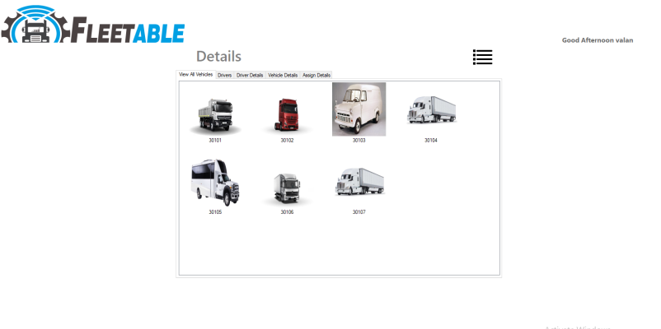

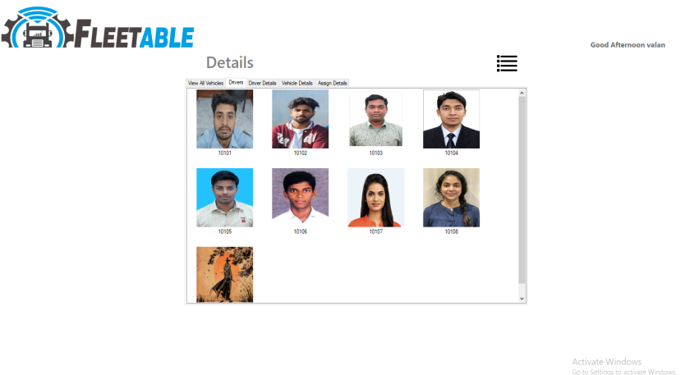

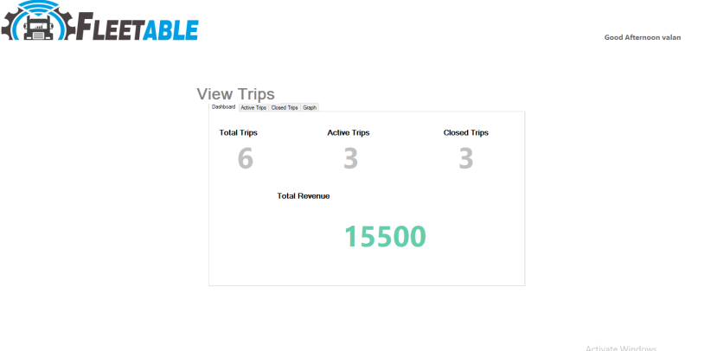

**Conclusion**

The **FleetCrypt Secure** project represents a significant advancement in the realm of fleet management, addressing the critical need for enhanced security and operational efficiency in managing vehicle fleets. By integrating robust encryption and hashing techniques—specifically AES for data encryption and SHA-256 for data integrity—**FleetCrypt Secure** ensures the confidentiality and protection of sensitive information against unauthorized access and potential breaches.

The dual-layered security approach not only safeguards driver records and trip assignments but also instills trust among users and stakeholders. The system's user-friendly interface and role-based functionalities streamline administrative tasks, enabling fleet managers to efficiently oversee operations while allowing drivers to manage their assignments effectively.

As the project evolves, the potential for future enhancements—such as real-time GPS tracking, machine learning analytics, and cloud integration—positions **FleetCrypt Secure** to adapt to the dynamic needs of the fleet management industry. These advancements will further optimize operations, improve decision-making, and ensure sustainability, ultimately contributing to enhanced resource management and operational excellence.

In summary, **FleetCrypt Secure** is not just a fleet management system; it is a comprehensive solution designed to meet the challenges of modern fleet operations, ensuring security, efficiency, and a proactive approach to managing vehicle fleets in an ever-changing landscape.

**References**

* National Institute of Standards and Technology (NIST). (2001). Announcing the Advanced Encryption Standard (AES). NIST Publication.
* Menezes, A. J., van Oorschot, P. C., & Vanstone, S. A. (1996). Handbook of Applied Cryptography. CRC Press.
* Ferguson, N., Schneier, B., & Kohno, T. (2010). Cryptography and Network Security: Principles and Practice. Prentice Hall.
* Khan, M. K. (2015). Cryptography and Network Security: A Primer. Springer.
* Sullivan, J. (2019). Understanding SHA-256: The Secure Hash Algorithm. Medium Article.
* Stallings, W. (2017). Cryptography and Network Security: Principles and Practice. Pearson.
* Eastlake, D., & Jones, P. (2001). RFC 3174: US Secure Hash Algorithm 1 (SHA1). IETF. Available Online
* National Institute of Standards and Technology. (2012). SHA-256 Standard.
* Daemen, J., & Rijmen, V. (2002). The Design of Rijndael: AES - The Advanced Encryption Standard. Springer.
* Karp, B., & Kung, H. (2000). GPS-based vehicle tracking: What you need to know. IEEE Network, 14(2), 46-50.
* Bandyopadhyay, S., & Bhattacharya, S. (2017). Internet of Things: Applications and Future Directions. Springer.
* GDPR (General Data Protection Regulation). (2016). Regulation (EU) 2016/679 of the European Parliament and of the Council.
* Privacy International. (2018). A Guide to Data Protection and Privacy

**Authors**

|  |  |
| --- | --- |
|  | Name: Rahul Bennet M.  Department: II MCA  Reg No: 230334  College:Scott Christian College |
|  | Name: Valan Rishi  Department: II MCA  Reg no: 230323  College: Scott Christian College |
|  | Name: Melba.D  Department: II MCA  Reg no: 230324  College: Scott Christian  College |
|  | Name: Melba.D  Department: II MCA  Reg no: 230324  College: Scott Christian College. |